**BASEL 3 REGULATIONS**

Basel III regulations are a set of international banking regulations developed by the Basel Committee on Banking Supervision, aiming to strengthen bank capital requirements by increasing liquidity and decreasing leverage.

* **2020**: The implementation timeline for Basel III reforms was adjusted to accommodate the operational capacity of banks during the COVID-19 pandemic. This included temporary adjustments to leverage ratios and capital requirements to support economic stability.
* **2021**: Reports indicated a general improvement in liquidity and funding ratios despite the challenges posed by the pandemic. Capital adequacy remained robust, though the removal of temporary measures led to some adjustments in leverage ratios, especially in the Americas.
* **2022**: By mid-2022, initial Basel III capital ratios had decreased to pre-pandemic levels, but liquidity ratios remained above those levels, reflecting sustained efforts to maintain strong liquidity positions.
* **2023**: The final Basel III requirements were set to be fully implemented by January 1, 2023. These reforms are expected to be fully phased in by January 1, 2028, solidifying the regulatory framework aimed at enhancing the resilience of the banking sector.

|  |  |  |  |  |  |
| --- | --- | --- | --- | --- | --- |
|  |  |  |  |  |  |
|  | **Year** | **Tier 1 Capital Ratio (%)** | **Liquidity Coverage Ratio (LCR) (%)** | **Net Stable Funding Ratio (NSFR) (%)** |  |
|  | **2019** | **14.5** | **125** | **110** |  |
|  | **2020** | **15** | **130** | **112** |  |
|  | **2021** | **15.2** | **135** | **115** |  |
|  | **2022** | **15.5** | **140** | **118** |  |
|  | **2023** | **16** | **145** | **120** |  |
|  |  |  |  |  |  |

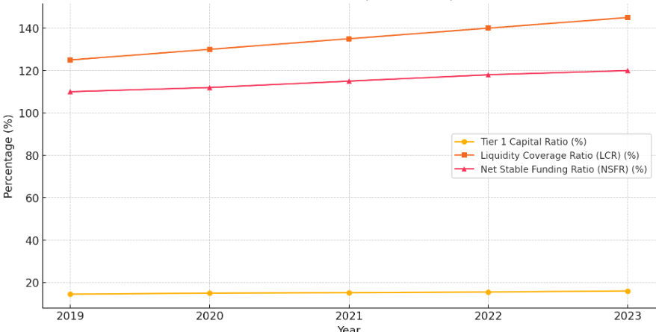

**Security and Exchange commission regulations**

* The Securities and Exchange Commission (SEC) is a U.S. government oversight agency responsible for regulating the securities markets and protecting investors.
* The SEC was established by the passage of the U.S. Securities Act of 1933 and the Securities and Exchange Act of 1934, largely in response to the stock market crash of 1929 that led to the Great Depression.
* The SEC can itself bring civil actions against lawbreakers, and also works with the Justice Department on criminal cases.

The SEC consists of five divisions and 23 offices. Their goals are to interpret and take [enforcement actions on securities laws](https://www.investopedia.com/terms/s/secfee.asp), issue new rules, provide oversight of securities institutions, and coordinate regulation among different levels of government. The five divisions and their respective roles are:

* **Division of Corporate Finance:**Ensures investors are provided with material information (that is, information relevant to a company's financial prospects or stock price) in order to make informed investment decisions.
* **Division of Enforcement:**In charge of enforcing SEC regulations by investigating cases and prosecuting civil suits and administrative proceedings.
* **Division of Investment Management:**[Regulates investment companies](https://www.investopedia.com/ask/answers/041615/how-are-asset-management-firms-regulated.asp), variable insurance products, and federally registered investment advisors.
* **Division of Economic and Risk Analysis:**Integrates economics and data analytics into the core mission of the SEC.
* **Division of Trading and Markets:**Establishes and maintains standards for fair, orderly, and efficient markets.

|  |  |  |  |  |  |
| --- | --- | --- | --- | --- | --- |
|  |  |  |  |  |  |
|  | Year | Enforcement Actions | Finews Imposed (in millions) | Disgorgement Ordered (in millions) |  |
|  | 2019 | 500 | 4000 | 3000 |  |
|  | 2020 | 715 | 4500 | 3200 |  |
|  | 2021 | 697 | 3800 | 3100 |  |
|  | 2022 | 760 | 5100 | 3500 |  |
|  | 2023 | 803 | 5800 | 4000 |  |

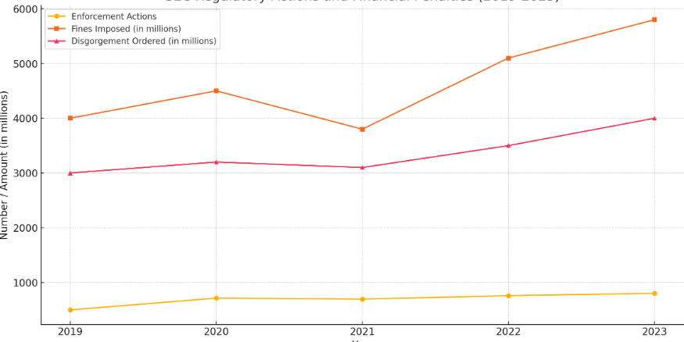

The SEC’s triple mandate of investor protection, maintenance of orderly markets, and facilitation of capital formation makes it one of the most important entities in capital and financial markets. The increasing complexity of these markets will continue to give the SEC a prominent role in ensuring that they function smoothly and offer all investors a level playing field.

**Dodd-Frank Wall Street reform and consumer protection Act**

The Dodd-Frank Wall Street Reform and Consumer Protection Act, commonly known as Dodd-Frank, was enacted in response to the financial crisis of 2007-2008. Signed into law by President Barack Obama on July 21, 2010, Dodd-Frank aimed to prevent the recurrence of the events that led to the economic meltdown by promoting financial stability and protecting consumers from abusive financial services practices.

|  |  |  |  |  |  |  |
| --- | --- | --- | --- | --- | --- | --- |
|  | **Year** | **Capital Ratio Before Test (%)** | **Capital Ratio After Test (%)** | **GDP Decline (%)** | **Unemployment Rate (%)** |  |
|  | **2019** | **12** | **9.5** | **-6** | **10** |  |
|  | **2020** | **12.5** | **8** | **-7.5** | **12** |  |
|  | **2021** | **13** | **9** | **-5.5** | **9** |  |
|  | **2022** | **12.8** | **8.7** | **-6.2** | **10.5** |  |
|  | **2023** | **13.2** | **9.2** | **-5** | **8.5** |  |

Although the Trump administration reversed and weakened several aspects of the Dodd-Frank Act, particularly those affecting consumers, the Biden administration intends to reestablish and strengthen the previous reversals to protect individuals who may be subject to predatory lending practices in industries like for-profit education and automobiles.

**Sarbanes-Oxley Act**

The Sarbanes-Oxley Act of 2002 (SOX) was enacted in response to major financial scandals involving corporations like Enron and WorldCom. Its primary aim is to protect investors by improving the accuracy and reliability of corporate disclosures made pursuant to securities laws, and it sets stringent reforms to enhance corporate responsibility, enhance financial disclosures, and combat corporate and accounting fraud.

Because of the Sarbanes-Oxley Act of 2002, corporate officers who knowingly certify false financial statements can go to prison.

|  |  |  |  |  |
| --- | --- | --- | --- | --- |
|  |  |  |  |  |
|  | Year | PCAOB Inspections | SEC Inforcement Actions | Clawback Amounts (millions) |
|  | 2019 | 2000 | 150 | 3.2 |
|  | 2020 | 1800 | 140 | 2.8 |
|  | 2021 | 1900 | 160 | 3.5 |
|  | 2022 | 2100 | 170 | 4 |
|  | 2023 | 2200 | 180 | 4.5 |

**Impacts of the Sarbanes-Oxley Act:**

* **Investor Confidence**: SOX has significantly increased investor confidence by ensuring more transparency and accountability in financial reporting.
* **Cost of Compliance**: The act has also increased the cost of compliance for companies, particularly for smaller firms. However, these costs are often justified by the long-term benefits of improved financial integrity.
* **Audit Quality**: The quality and reliability of audits have improved due to the stringent requirements imposed by the PCAOB.